N n O o P p Q q R r S s T t U u V v W w X x Yy Z z

t says t in 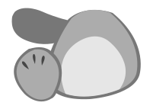 teddy.
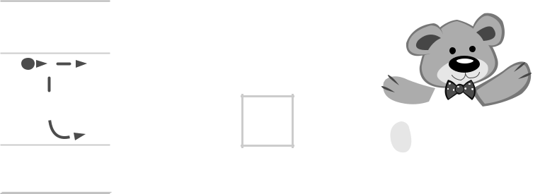

Trace

Copy t
Copy teddy ddy ddy
f says f in  fig.
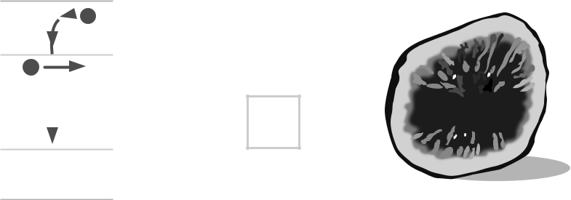

Trace

Copy f

Copy fig  ig ig


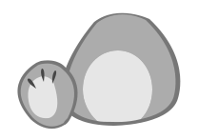 The teddy has a fig.


Family and Friends Special Edition Grade 1 | 18 | © Oxford University Press
Expansion Portfolio Unit 2 | 18 | Permission granted to reproduce for instructional use.

A a B b C c D d E e F f G g H h I i J j K k L l M m

Circle and color the correct letter.
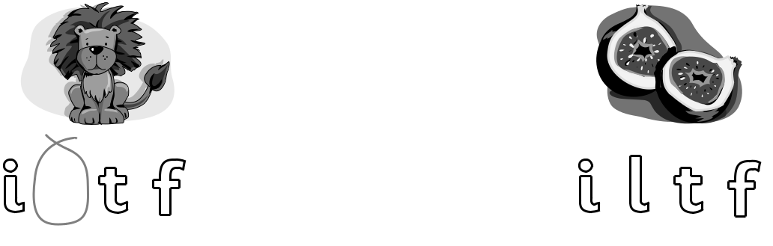

l




Match and write.


i


l

t

f

ingers


en
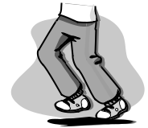

egs


- ce cream

Family and Friends Special Edition Grade 1 | 19 | © Oxford University Press
Expansion Portfolio Unit 2 | 19 | Permission granted to reproduce for instructional use.

N n O o P p Q q R r S s T t U u V v W w X x Yy Z z

Match and write t or f .

2


4

5

10

en

ive

our

- wo

Find and circle.

i

e

l

o

t

a

six | pink | bike | fingers
hello | yellow | eraser | leg
blue | pencil | apple | puzzle
window | dog | doll | nose
eight | cat | teacher | hat
bag | orange | ball | hand

Family and Friends Special Edition Grade 1 | 20 | © Oxford University Press
Expansion Portfolio Unit 2 | 20 | Permission granted to reproduce for instructional use.

A a B b C c D d E e F f G g H h I i J j K k L l M m
r says r in  rabbit.





Trace

Copy r

Copy rabbit abbit abbit
n says n in  nurse.

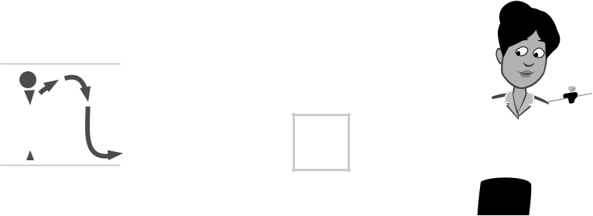

Trace

Copy n

Copy nurse urse urse


 The nurse has a rabbit.


Family and Friends Special Edition Grade 1 | 21 | © Oxford University Press
Expansion Portfolio Unit 2 | 21 | Permission granted to reproduce for instructional use.


Unit 2 Handwriting practice

- Trace the lines.

- Write the letters.

E


e

F


f

- Write the numbers.
5 6


Family and Friends Special Edition Grade 1 | 22 | © Oxford University Press
Expansion Portfolio Unit 2 | 22 | Permission granted to reproduce for instructional use.


_{Unit} 2 Values

Play respectfully


1 Look and draw.
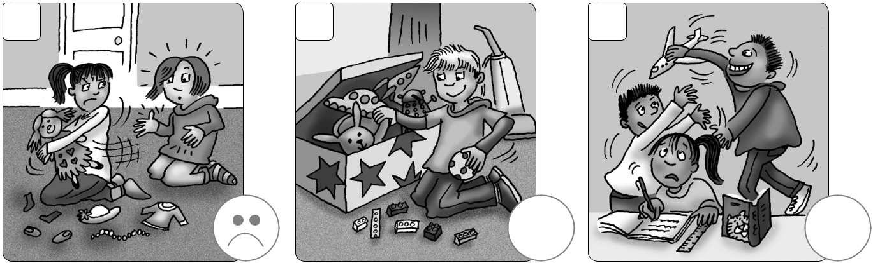

1 2 3
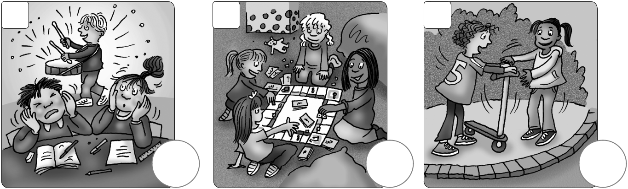

4 5 6

- Color and say.
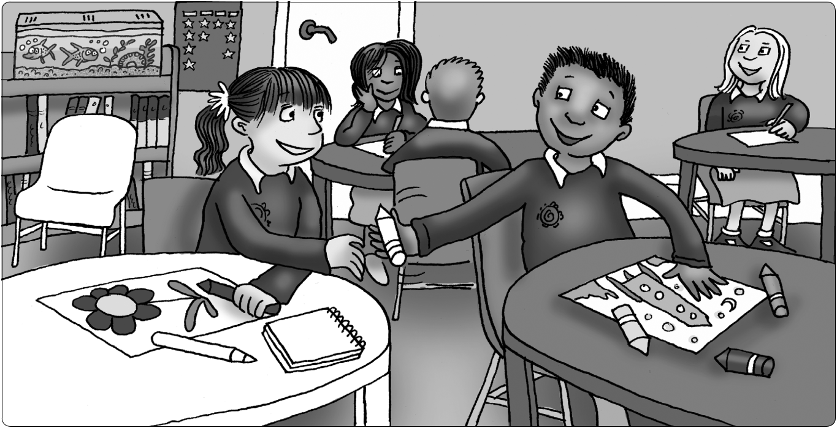

Family and Friends Special Edition Grade 1 | 23 | © Oxford University Press
Expansion Portfolio Unit 2 | 23 | Permission granted to reproduce for instructional use.

Unit test

- Look and match.
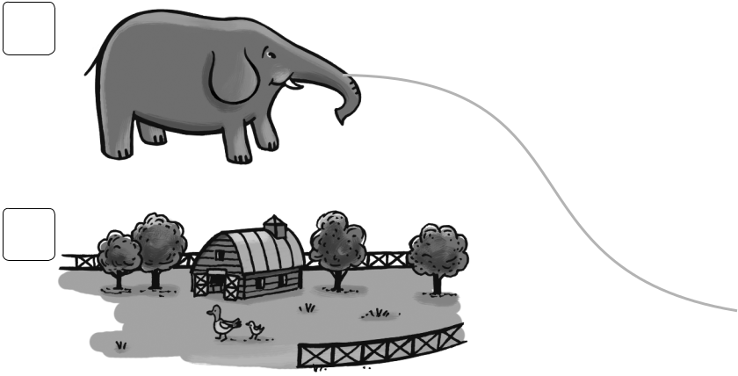

1

2
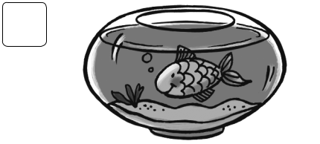

3


4

- Count and circle.
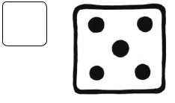

1
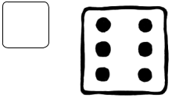

2


3


4

/ 3


f

e

e

f

/ 3


5 6

5 6

5 6

5 6


/12

Family and Friends Special Edition Grade 1 | 25 | © Oxford University Press
Expansion Portfolio Unit 2 | 25 | Permission granted to reproduce for instructional use.

